Verify Login Without Data

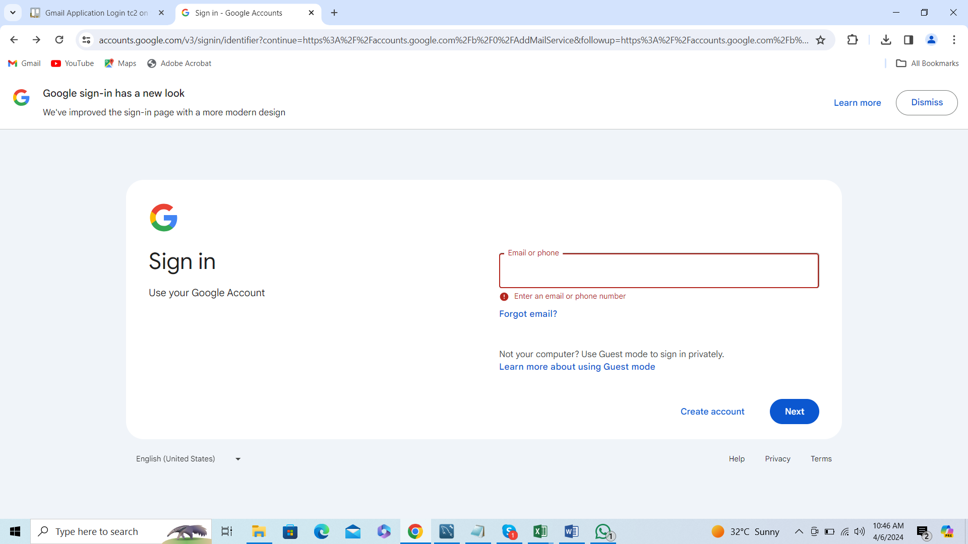

Error message is displayed